Note: if you are uploading back issues that have already been published, it is important to publish them immediately before uploading the articles that are part of this back issue. After publishing the issue, you can find the issue you just published via Issues > Back Issues. Among other things, you will need to change the publication date of the issue by clicking on the blue triangle, then 'Edit' and then the 'Issue data' tab. Under the heading 'Date Published', you can change the publication date. It is necessary to publish the back issue first before uploading articles from that same back issue, because the publication date you enter per article in the Quick Submit Plugin is exceeded by the publication date of the back issue.

Working with the OpenJournals Quicksubmit Plugin
This is how you can use the OpenJournals Quicksubmit Plugin:
- Navigate to Tools, then click on the Quicksubmit Plugin.
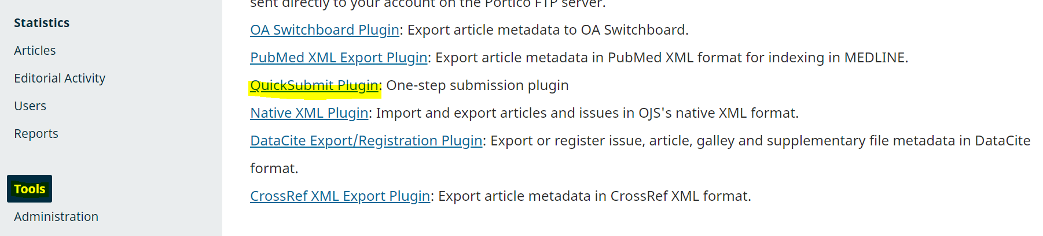
- The quicksubmit plugin contains many different fields to complete. Here is an overview of what each field entails:
Name of field | Information to Enter
Cover Image | Here you can upload an image to go along with the article.
Section | This determines what section of the journal the article will be in (e.g. Articles or bookreviews)
Prefix | If the title of the article starts with a prefix like ‘the’ or ‘a’, put that prefix here.
Title | The title of your article, without any prefixes.
Subtitle | An optional subtitle for the article.
Abstract | The Abstract of the article.
Keywords | Keywords that you’d like to be associated with the article.

- In order to add contributors to the article, you press the Add Contributor button, which causes an extra screen to pop up. It contains these fields:
Name of field | Information to Enter
Name | The first name of the contributor
Family Name | The last name of the contributor
Contact | The email address of the contributor
Country | The country of the contributor
Hompage URL/ORCID ID/Affiliation | Additional information on the contributor you can add if the contributor would like it.
Bio statement | A place to add a short biography of the contributor, if desired.
Contributors role | Choose whether the contributor is an author or a translator.
Principal contact for editorial correspondence. | Check this box if you’d like responses to the article to primarily go to this author.
Include this contributor in browse lists? | This box is checked by default and should generally remain checked.

- In order to include a file that contains the actual article (e.g. the PDF or XML), you can click Add Galley.
- This brings up a screen with the following fields:

Name of field | Information to Enter
Galley Label | The label for the button linking to the file; generally you’d use the file extentions (e.g. PDF when uploading a PDF, etc).
Language | The language of the file
URL Path | Should remain empty.
This galley will be available at a separate website. | Should remain unchecked.

- When you click save afterwards, you get onto the next screen, where you can upload the actual file. Select what ‘Article Component’ this is (e.g. article text or something else), then upload the file.
- Click Continue.
- On the next screen, you can edit the name of the file (this is the name of the file as it will appear when it is downloaded).
- Click Continue → Complete.

- Decide whether the article is unpublished (you want to finish the process in the regular publishing interface) or published (you want to finish the process in the quicksubmit-tool).
- If you choose to publish through the quicksubmit tool, these fields appear:
Name of field | Information to Enter
Schedule for publication in | Allows you to choose an issue to publish in.
Pages | Fill in what pages in that issue this article takes up, if relevant.
Published | The date of publication for this article.
License URL | A link to a specific license, if relevant.
Copyright Holder | Information about the copyright holder, if relevant
Copyright year | Self-explanatory, only if relevant.

- Finally, you can click save to put the article into the system.

